|  |  |  |
| --- | --- | --- |
| **Guide Name** | | **Panel Head** |
|  | Mrs. Vijayalakshmi V | Dr. P. Balamurugan |
|  |  |  |
|  | **Faculty Advisor** | **Project Domain** |
|  | Mr. J Prabakaran | AI, Finance |
| M |  |  |
|  | **Student(s) Details: Name** | **Passport size photo(s)** |
|  | 1. Rachit Sood  2. Papai Mondal  3. Asmi Shrivastava |  |
|  |  |  |

Registration Number(s)



1. RA2111028010110

2. RA2111028010116

3. RA2111028010119

**Email ID(s)&Mobile Number(s)**

|  |  |
| --- | --- |
| 1: [rd7384@srmist.edu.in](mailto:rd7384@srmist.edu.in)  7876652417 | 2: [pk0562@srmist.edu.in](mailto:pk0562@srmist.edu.in)  9511743369 |
| 3: as6252@srmist.edu.in  8305326507 |  |

**Abstract Architecture Diagram**

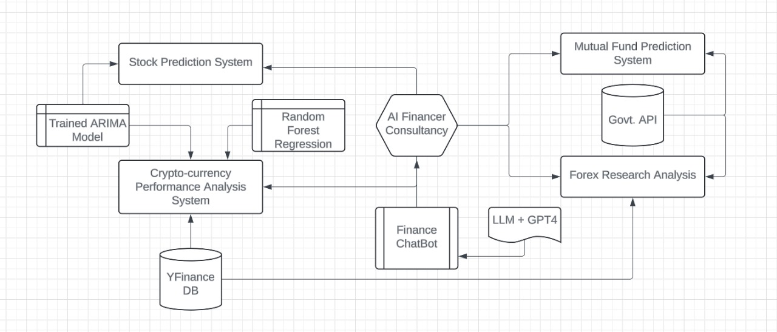

The research aims to enhance AI-based personal finance advisors for stock market investments by addressing critical challenges identified in existing systems. The objectives include improving algorithmic flexibility, bolstering data security, and mitigating algorithmic bias to ensure fair and equitable recommendations. The study also focuses on increasing transparency and explainability of AI models, aligning them with regulatory standards to build investor trust, and integrating behavioural finance insights to capture investor sentiments more accurately. Through these advancements, the research seeks to create a more reliable, secure, and user-centric AI-driven financial advisory system.

**Significance of the Project Conclusion**

This project aims to revolutionize financial advisory services by offering real-time, personalized recommendations and integrated solutions for managing diverse financial assets. It addresses the inefficiencies of traditional methods, ensuring optimized investment decisions and seamless financial management for enhanced user experience financial outcomes.

This research develops an AI-based personal finance advisor focused on stock market investments, utilizing cloud computing to enhance performance, scalability, and real-time decision-making. The system tackles key challenges like data security, algorithmic bias, and transparency, ensuring that users receive reliable and personalized financial advice. By integrating advanced AI models and cloud infrastructure, the solution makes investment guidance more accessible, affordable, and accurate.

**Conference/Citation (Mandatory)**

Hui Zhu, Olli Vigren, Inga-Lill Söderberg,

Implementing artificial intelligence empowered financial advisory services: A literature review and critical research agenda,

Journal of Business Research,

Volume 174,

2024,

114494,

ISSN 0148-2963,

https://doi.org/10.1016/j.jbusres.2023.114494.

(https://www.sciencedirect.com/science/article/pii/S0148296323008536)

Abstract: Robo-advisors, also known as robo-advisory services, significantly reshape customer service in financial advisory industries, transforming retail investor markets by substituting human financial advisory experts with artificial intelligence empowered services.